Sprint 3 – Agility Design Document

December 1, 2021

Table of Contents

1. Executive Summary 3

1.1 Project Overview 3

1.2 Purpose and Scope of this Specification 3

2. Product/Service Description 3

2.1 Product Context 3

2.2 User Characteristics 3

2.3 Assumptions 3

2.4 Constraints 3

2.5 Dependencies 4

3. Requirements 4

3.1 Functional Requirements 5

3.2 Security 5

3.2.1 Protection 5

3.2.2 Authorization and Authentication 6

3.3 Portability 6

4. Requirements Confirmation/Stakeholder sign-off 6

5. System Design 6

5.1 Algorithm 6

5.2 System Flow 6

5.3 Software 6

5.4 Hardware 6

5.5 Test Plan 7

5.6 Task List/Gantt Chart 7

5.7 Staffing Plan 7

# Executive Summary

## Project Overview

This product is one leg of a larger product testing the abilities of the Sphero SPRK+ robot using different courses / sprints. Each course is located on the floor of room HH-208. This part of the project is called the Agility sprint. The goal is for the robot to navigate the path while interacting or avoiding interaction with various items. Some items are obstacles to be avoided, one is a ramp for the robot to jump, and the rest are pins to be knocked down by the robot.

A video will be taken of the robot completing the sprint. It will then be turned in to the professor alongside the block code and other requested information.

## Purpose and Scope of this Specification

In scope

This part of the project involves testing for Agility only, as explained in section 2.1.

Out of Scope

This part of the project does not involve testing for Endurance or Accuracy, both being already completed parts of the project.

# Product/Service Description

## Product Context

This product is part of a larger project containing three different sprints- Endurance, Accuracy, and Agility. This is the third and last of the three products- the Agility sprint. All three of these products will be presented through video inside of a larger presentation, alongside other relevant information.

## User Characteristics

* Our group of three students will be using the product during testing and while taking the final video of the sprint. We have some experience using the robot from the previous two sprints. This sprint is especially similar to the first in terms of the robot’s movement, which could make development easier. Some of us have experience with software development in general and at least one of us has used JavaScript-based block code before.

The professor may also be testing our code.

## Assumptions

We are to use an SPRK+ robot and the Sphero Edu application for development. We must use the predetermined course located inside room HH-208. The application can be used on mobile or on a laptop, meaning that the robot can be run from either device. We are using a phone to film the robot, as the mobile app allows users to run the robot and film it simultaneously.

## Constraints

Room HH-208, which contains the course for the Agility sprint, is not always available, therefore limiting the times at which the group can meet and test the robot. However, this was not as much of a problem for this sprint, as we had one period of class time where we were allowed to work, meaning that fewer people stayed in the room afterwards. Our group had some time constraints, but we were ultimately able to complete the block code in a timely manner for this sprint. We did still have to accept a run that was not entirely perfect due to these time constraints, however.

## Dependencies

Any dependencies are explained inside the requirements chart in section 3.1.

# Requirements

## Functional Requirements

| Req# | Requirement | Comments | Priority | Date Rvwd | SME Reviewed / Approved |
| --- | --- | --- | --- | --- | --- |
| AGIL_01 | Robot will start in square | Indicated by a plus sign shape on the course, which is made of blue tape | 1 | 11/23 | 11/23 |
| AGIL_02 | Robot will encounter 3 objects that it must avoid | These 3 objects are the glass bottles placed near turns in the course | 1 | 11/23 | 11/23 |
| AGIL_03 | Robot will go over the ramp | The ramp is a binder that the robot will have to climb and land on the other side of | 1 | 11/23 | 11/23 |
| AGIL_04 | Robot will knock over as many pins as possible | The pins are 10 dry erase markers | 1 | 11/23 | 11/23 |

## Security

### Protection

We did not feel that it was worth putting more extreme protective measures on our program. We did use a password protected account on the Sphero Edu application, however, that would protect our code. The robot itself is also secured inside of a case when not being used.

### Authorization and Authentication

N/A

## Portability

This system is overall not portable. The track is located in HH-208, and therefore the robot must be run in this room in order to follow the requirements. The robot itself and the device being used to run the robot can be moved around, but as the device must use Bluetooth to connect to and control the robot, the robot must be near the device in order to run.

# Requirements Confirmation/Stakeholder sign-off

|  |  |  |
| --- | --- | --- |
| Meeting Date | Attendees | Comments |
| 11/23 | Anjali, Jarek, James (all group members) | All requirements confirmed |

# System Design

## Algorithm

* Start on blue “x”
* Move forward to end of first line, avoiding obstacle
* Turn right 90 degrees
* Move forward to end of second line, avoiding obstacle
* Turn left 90 degrees
* Move forward to end of third line, avoiding obstacle
* Turn right 90 degrees
* Increase speed while moving forward to jump obstacle
* Move forward to end of fourth line and stop
* Turn towards pins on final blue line
* Move forward to knock down pins
* Stop in triangle

## System Flow

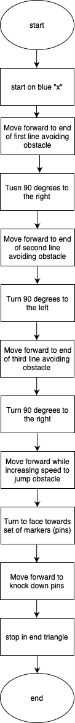

## Software

This product was initially programmed using the Sphero Edu application for Windows. The code was run during testing and edited accordingly using the Sphero Edu application for iPhone (iOS). This application uses block code.

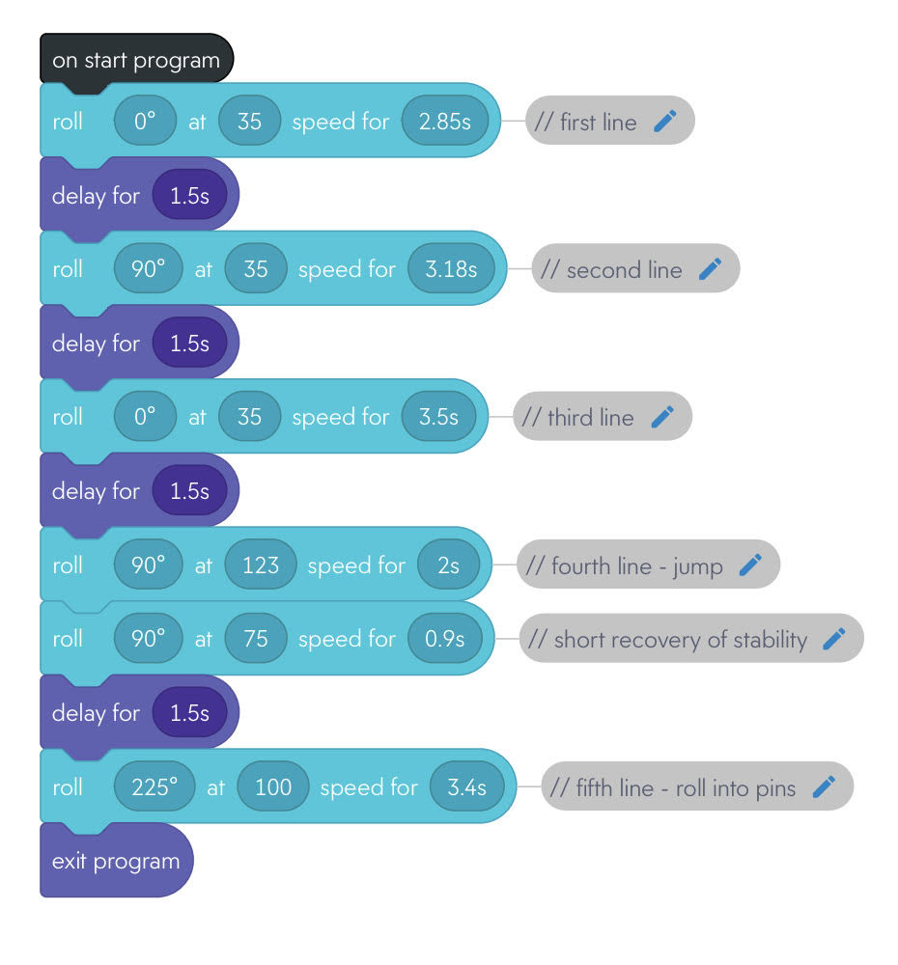

Block code for Agility sprint – Sphero Edu app for iOS

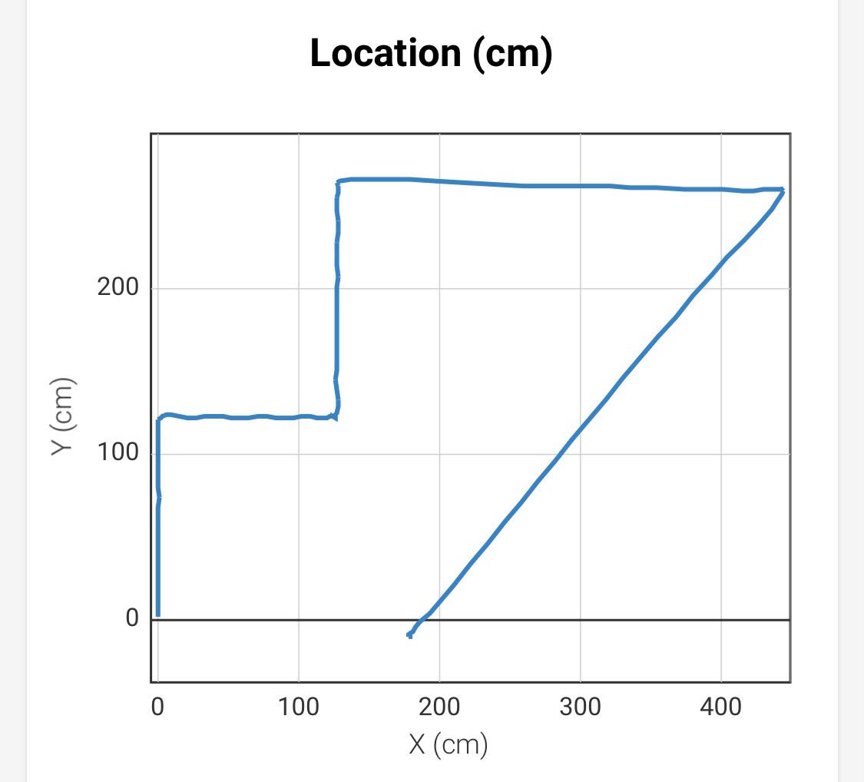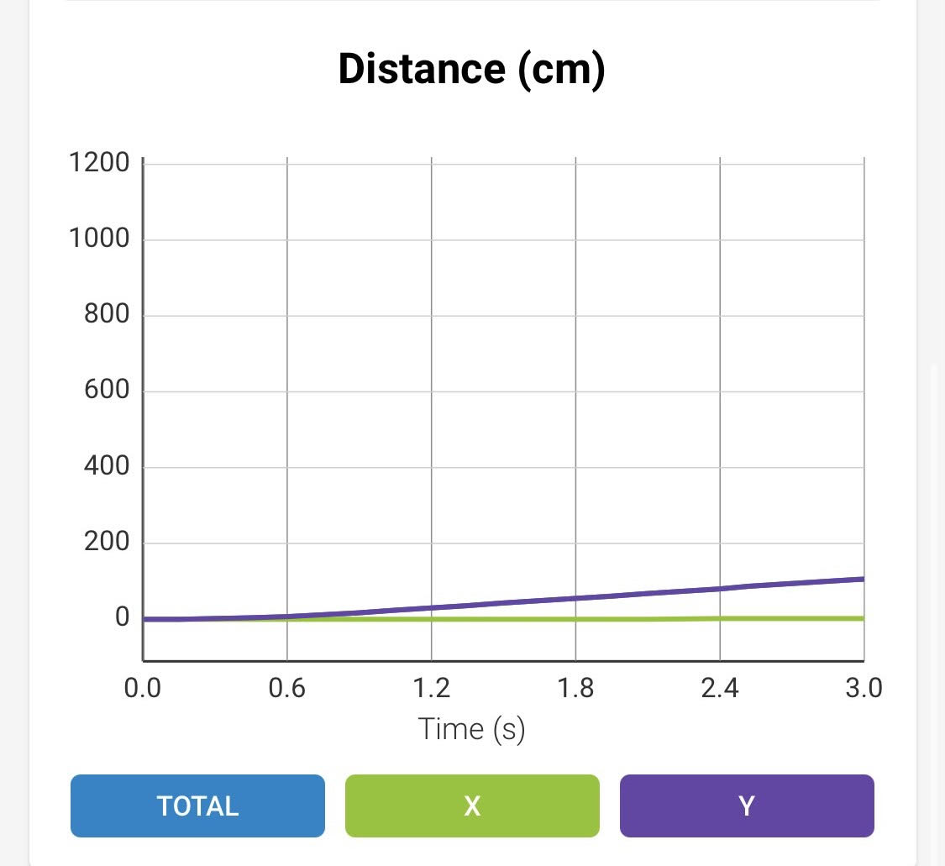

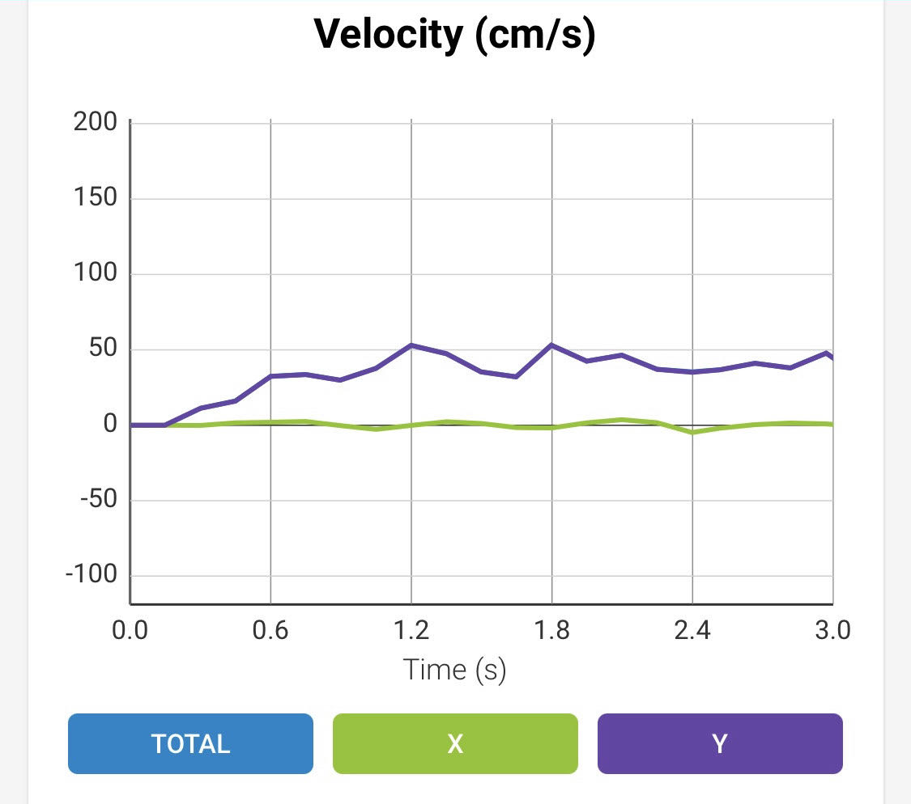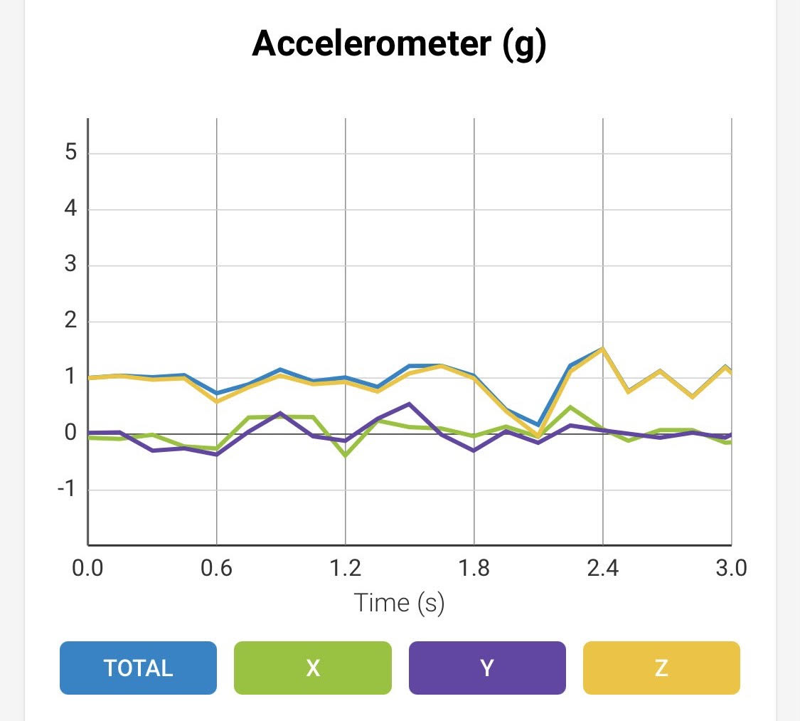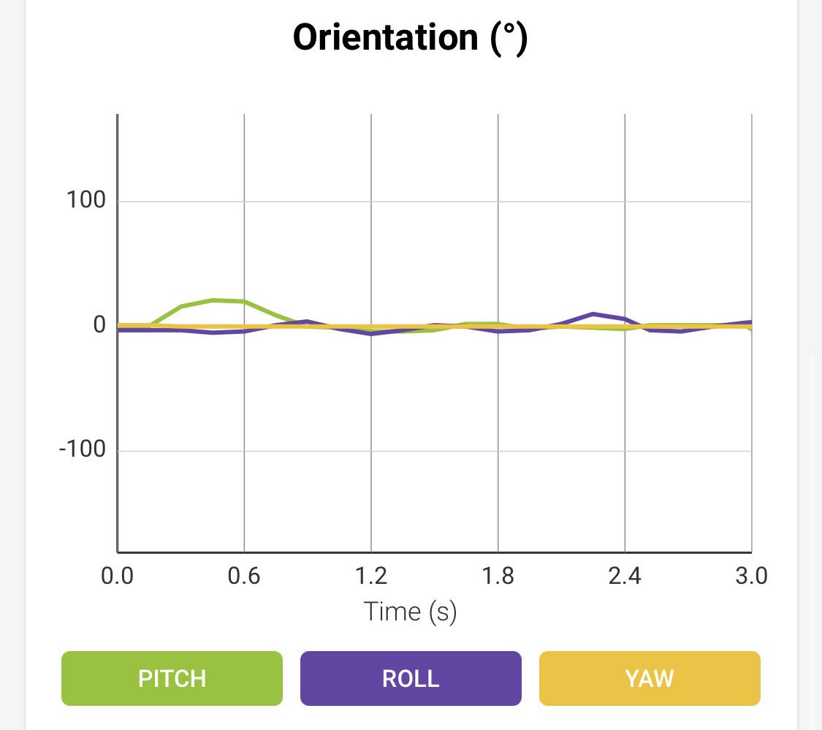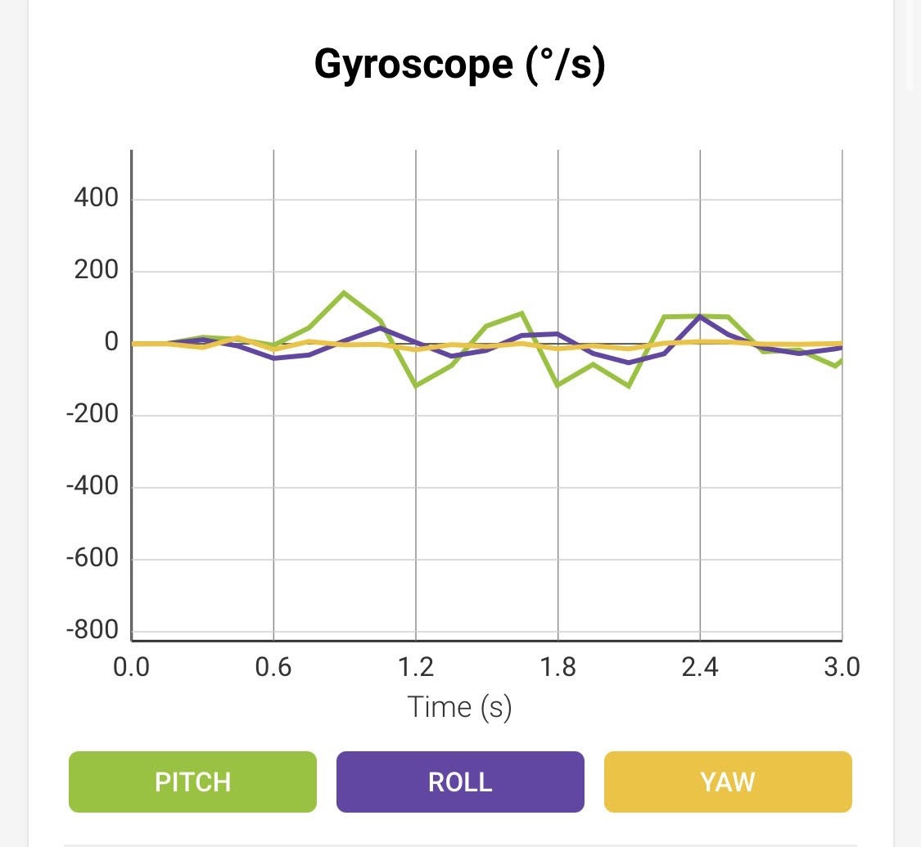

Sensor data diagrams – Sphero Edu app for iOS

## Hardware

The robot being used is the Sphero SPRK+. The block code was initially programmed using a laptop and subsequently edited using an iPhone. The robot was run and filmed using the iPhone as well.

## Test Plan

| **Reason for Test Case** | **Test Date** | **Expected Output** | **Observed Output** | **Staff Name** | **Pass/Fail** |
| --- | --- | --- | --- | --- | --- |
| Robot completes first line of sprint | 11/22 | Adjustments to the amount of time that the robot travels may be necessary. | The robot reached the end of the first line successfully, stopping at the end. | Jarek | Pass |
| Robot completes first 3 lines | 11/22 | As the lines are not exactly the same size, adjustments may be necessary to each duration. Robot may also need slight adjustments to the degree of each turn. | The robot stops short on the second line and on the third line. The duration should therefore be longer. The degree of any turn does not need to be adjusted, though. | Jarek | Fail |
| Robot completes first 3 lines | 11/22 | The robot should be closer to stopping at the end of each line after the previous adjustments. | The robot stopped about at the end of each line. Accepted as a pass. | Jarek | Pass |
| Robot completes the 4th line, jumping the ramp and landing on other end still on the course | 11/22 | It is expected that the robot will likely end up landing far away from the other side of the ramp for now. | The robot landed far away from the end of the ramp after climbing it. This was as expected, but not the goal. | Jarek | Fail |
| Robot moves along the course faster, as it wobbled while moving and this may have been due to slow speed | 11/23 | The robot should move faster and stay on the lines more accurately. However, it is expected that the robot will need adjustments to the duration of its movements due to the change in speed | The robot did not wobble while moving and did move faster, but it will need adjustments as expected.  Treated as a pass because the wobble stopped. | All | Pass |
| Robot completes first 3 lines | 11/23 | We are using trial and error based on the previous ratios (not exact) between the durations of the robot travelling each line. Therefore, it is expected that this test will not be perfect and will be used as a basis for changing the durations further. | The robot stopped at the end of the first line successfully but travelled too far on the second and stopped short on the third. | All | Fail |
| Robot completes first 3 lines | 11/23 | The robot should at least be closer to travelling to the end of each line successfully and not going too far or stopping short. | The robot stopped at the end of each line successfully. | All | Pass |
| Robot speeds up and jumps the ramp, landing on the other side of it and stopping | 11/23 | Slight adjustments may be necessary for the speed. The robot also may still land far away from the other end of the ramp. | The robot travelled for too long and did not stop directly on the other side of the ramp as we intended. The speed from last time this part was tested worked well, however. | All | Fail |
| Robot speeds up and jumps the ramp, landing on the other side of it and stopping | 11/23 | Changes to the duration were made, so the robot should stop directly on the other side of the ramp. | The robot jumped the ramp and landed close to the line on the other side of the ramp. | All | Pass |
| Robot speeds up and jumps the ramp, lands on the other side, and continues to the end of the fourth line | 11/23 | This is trial and error, so we may need to reduce the speed or duration of the robot (we opted to use two blocks for the fourth line where the robot travels again without stopping after making the jump to reach the end of the fourth line more slowly and more accurately) | The robot jumped the ramp successfully, landing on the other side, and travelled to about the end of the fourth line. The second block having lower speed seemed to make the robot’s movements more accurate as it moved towards the end, which is what was intended | All | Pass |
| Robot travels at correct degree in order to travel along the fifth and final line. Moves only slightly forward for now as a test | 11/23 | We measured with a protractor and will now use trial and error to figure out the degrees at which the robot should travel. There is some confusion even after measuring due to the way the block code works. | The robot did not turn the correct way and moved in the incorrect direction. | All | Fail |
| Robot travels at correct degree in order to travel along the fifth and final line. Moves only slightly forward for now as a test | 11/23 | The robot should face the correct way now while travelling along the fifth line. | The robot faced the correct way while moving, making it so that it stayed with the line on the course. | All | Pass |
| Robot travels along entire course as described, including entire fifth and final line, and stops at the far end of the triangle at the end of the course, knocking down all the pins inside the triangle | 11/23 | The robot is sped up a bit on the final line in order to try to knock down more pins and may not stop at the far end of the triangle as intended because this line has not been fully tested yet. The pins also may not all be knocked over. | The robot did stop where it was supposed to, but only 6 pins were knocked over, leaving 4 of the 10 still standing. This may have been because it moved slightly off of the last line while travelling, moving slightly diagonally and not hitting the middle of the 10 pins | All | Fail |
| Robot travels along entire course as described, including entire fifth/ final line, and stops at the far end of the triangle at the end of the course, knocking down all the pins inside the triangle | 11/23 | The robot may be off center when hitting the pins again, as no adjustments were made after the last test. This would mean that not all pins would be knocked over. | The robot was not off center this time and it stopped in the correct location. However, only 8 out of the 10 pins were knocked over. | All | Accepted as pass, as only issue was that robot knocked down 8/10 pins |

Note: Most tests are documented. However, some were repetitive / ended early due to small errors and can be represented within the tests that are documented in the table. The table is therefore still representative of the overall testing process.

## Task List/Gantt Chart

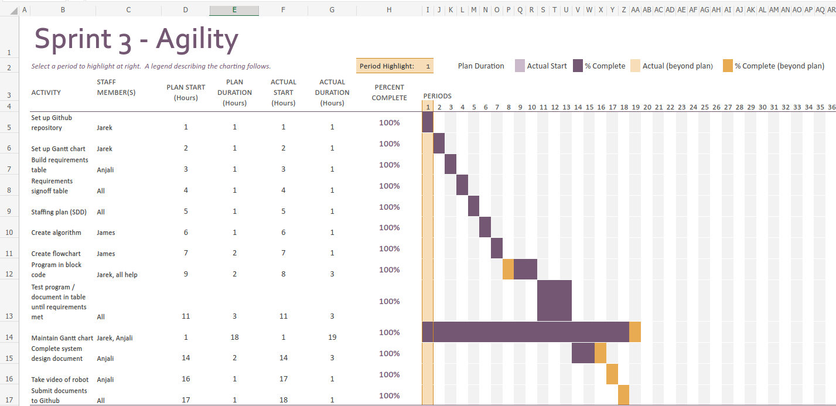

Link to Excel: <https://live365monmouth-my.sharepoint.com/:x:/g/personal/s1328134_monmouth_edu/ERdmLTXzzJ9CsAGctXS7feAB4vAr17A1lLQcj4HK4f-vFA?e=LCNl9z>

## Staffing Plan

| Name | Role | Responsibility | Reports To |
| --- | --- | --- | --- |
| Anjali | Manager | System Design Document, help with block code, robot video | Jarek for GitHub |
| James | Planning | algorithm, flowchart, help with block code | Anjali for System Design Document  Jarek for GitHub |
| Jarek | Lead Programmer | block code, Gantt chart, manage GitHub | Anjali for System Design Document |